Nama : Neng Lisda YS

Nia

Nim : 1147050124

1147050125

Kelas : IF-C

Tugas 6 Praktikum RPLL

1. Class Diagram Restoran Pizza

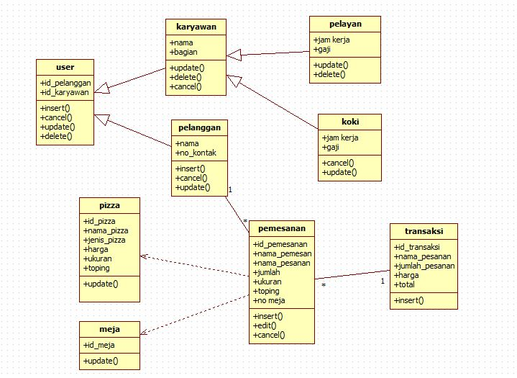

1. Sequence Diagram Restoran Pizza

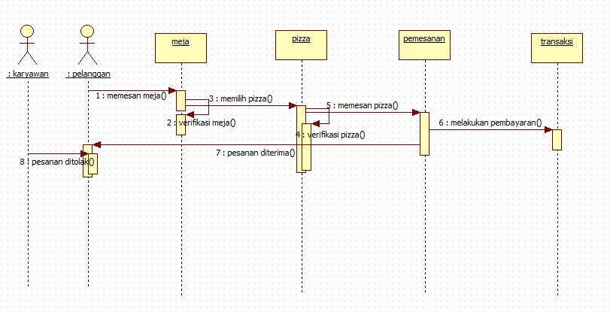

1. Collaboration Diagram Restoran Pizza

